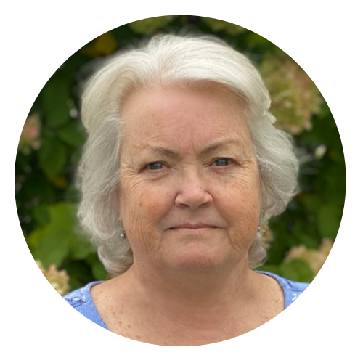 | Mary-Fran Rich
 | Settlement Coordinator
 | P: (603) 413-7083 | E: maryfran@greateasttitle.com
 | 1 Bedford Farms, Ste 203, Bedford, NH 03110
 | 

WARNING – FRAUDULENT WIRING INSTRUCTIONS
Email hacking and fraud are on the rise to fraudulently misdirect funds.
Please call us immediately using contact information found from an independent source to verify any funding instructions received. We are not responsible for any wires sent by you to an incorrect bank account.

